ASSIGNMENT NO -1

(PAKWHEELS)

Name: Yash Raj [25k-0878]

INTRODUCTION:
This Assignment is a console-based Car Marketplace System that simulates a platform similar to PakWheels. The program allows buyers and sellers to interact in a virtual car trading environment. Sellers can list vehicles with detailed specifications, buyers can browse and save favorite cars, and admins can manage and approve listings. The system is designed using Object-Oriented Programming concepts such as classes, constants, aggregation, and composition to demonstrate real-world software design principles in C++.

SYSTEM FEATURES AND IMPLEMENTATIONS

Vehicle Listing System
Sellers can add vehicles with complete details
Vehicle includes:
- Engine information
- Car features
- Price and specifications
Vehicles are stored inside the Marketplace
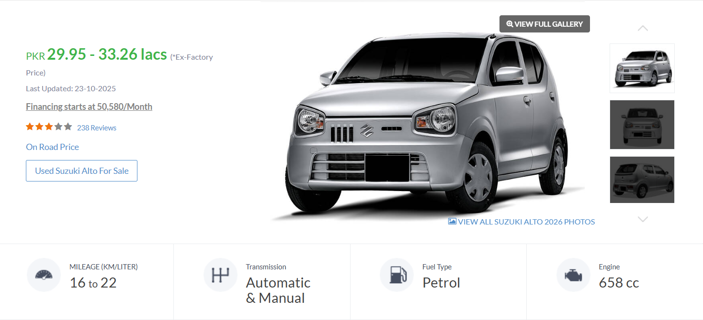
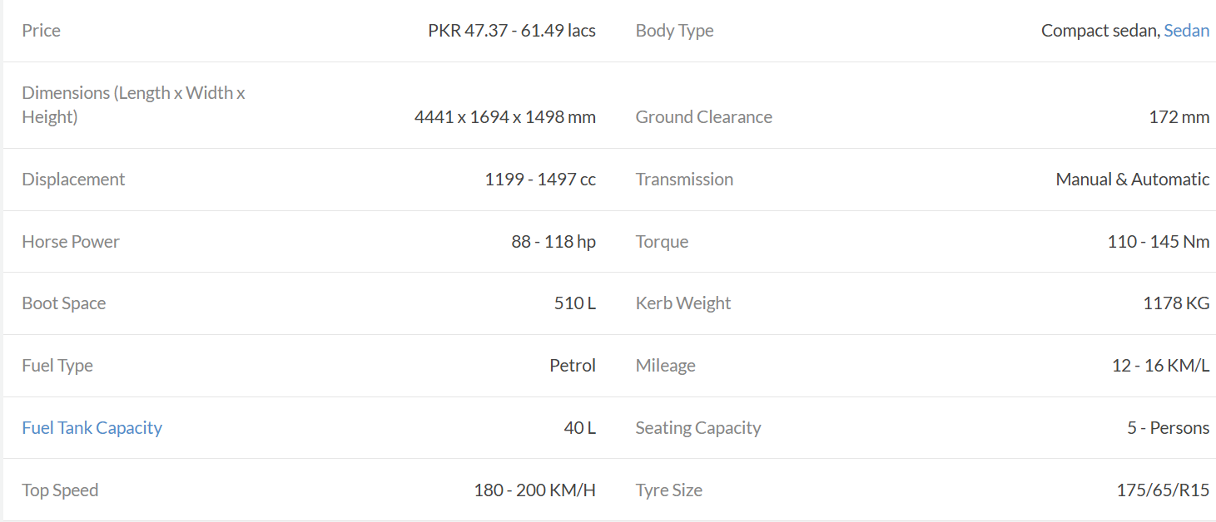

Car Information:
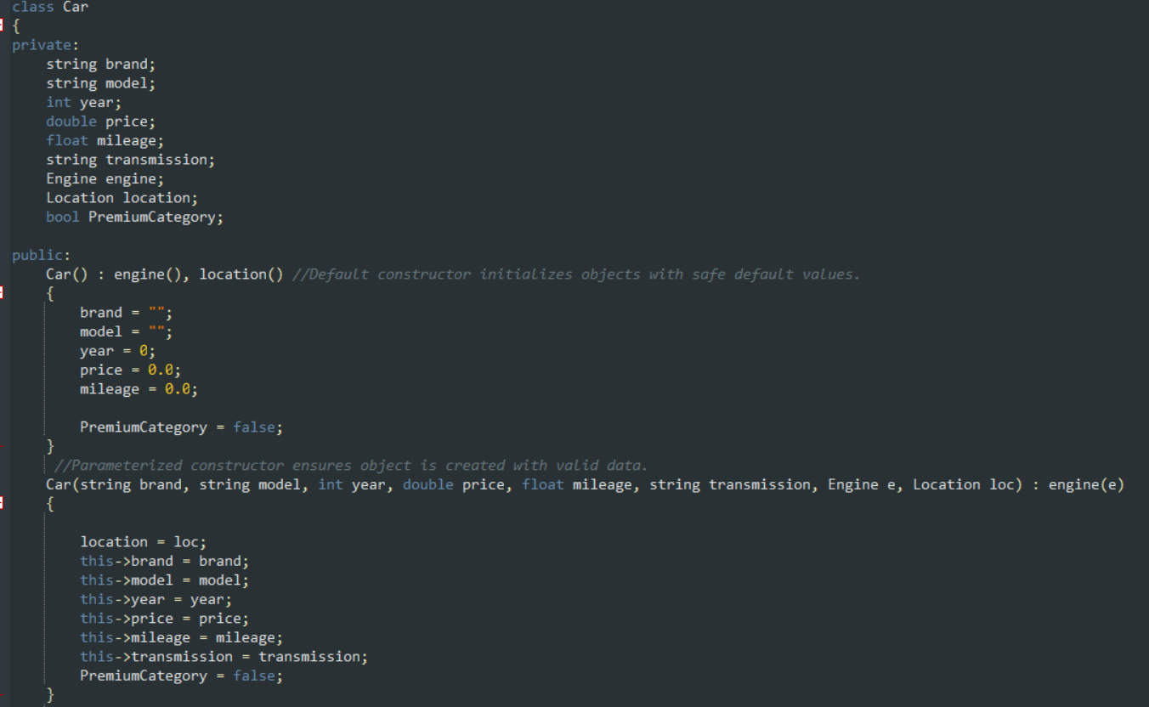\
Seller Information:
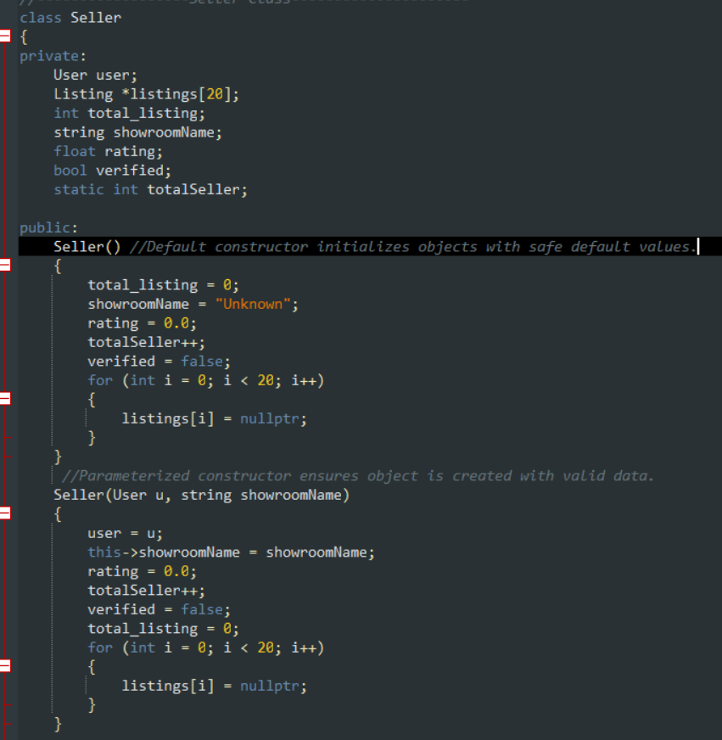

Market Place:
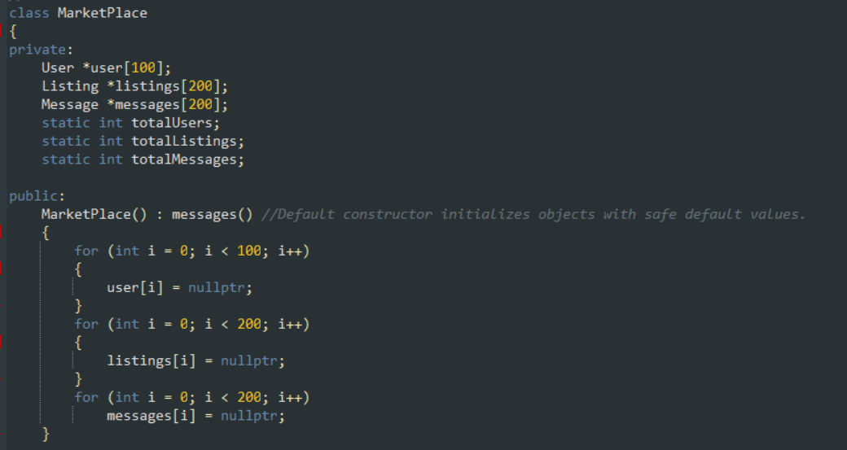

USER MANAGEMENT
- Separate roles: Admin, Seller, and Buyer
- Each role has its own data members and functions
- Admin manages the system activities
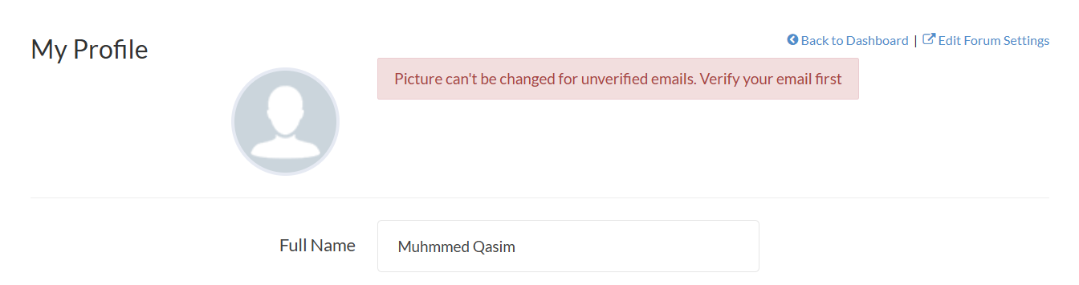
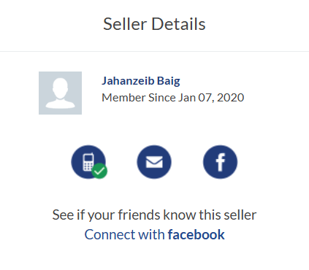
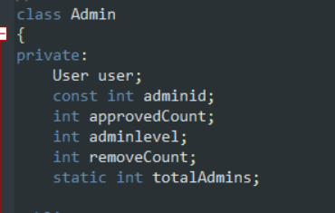
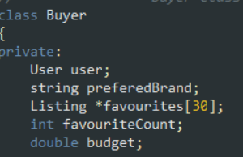

MESSAGING SYSTEM
- Buyers and sellers can communicate through messages
- Messages store sender and receiver information
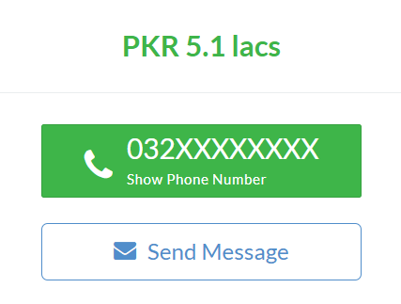
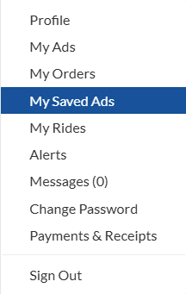
Buyer Can Send Message to Seller and it is saved in Marketplace:
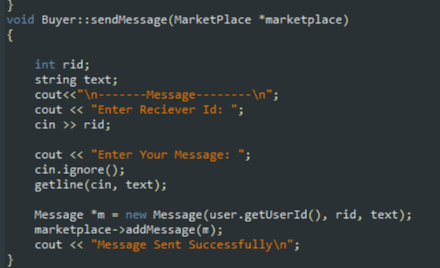
Message Class;
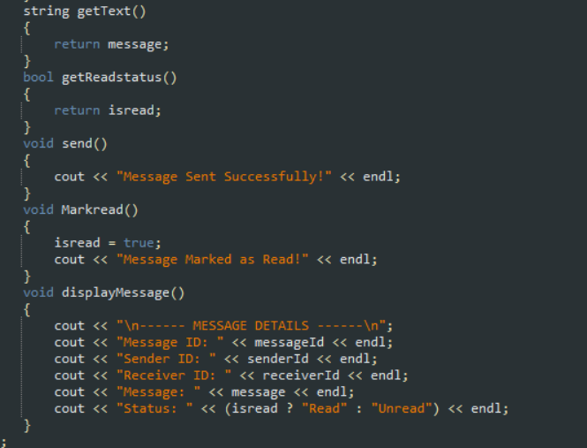

ADD TO FAVOURITE FEATURE :
The Add to Favorite feature allows buyers to save vehicles they are interested in for later viewing. When a buyer selects a vehicle, its reference (pointer) is stored in the buyer’s favorites list. This enables the buyer to quickly access preferred vehicles without searching again.

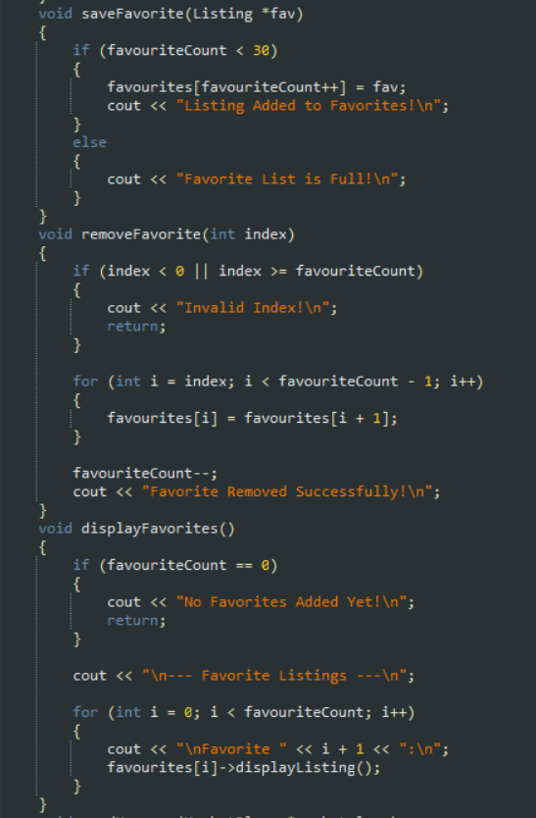

Class Diagram:
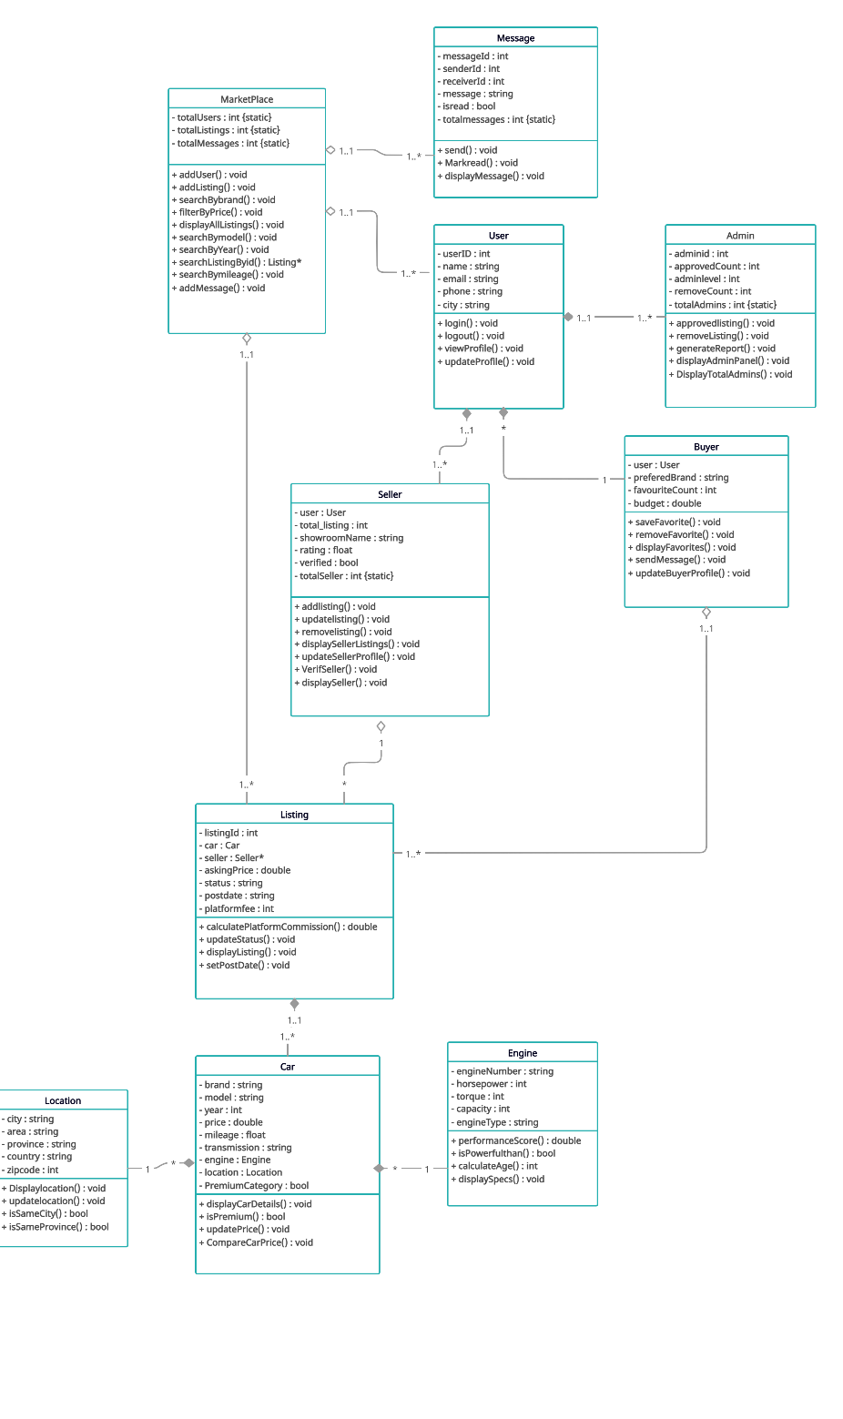

Main:
